Social Media Mining (CSE598)

Project Phase-1

-Karthik Vivekanandan (1207683239)

**Introduction**

Network analysis tools used: Snap.py, Networkx

Included in the submission is a requirements.txt file, which contains a simple list of all the packages used in my environment, and their respective versions. To re-create the environment to install the same packages using the same versions, one can use “pip install –r requirements.txt” to run these submitted programs. To use the crawler program, one needs to use their personal app and user tokens, these are not included in the submission.

**Twitter crawling**

Implemented a crawler to visit 1012 twitter users, through a user’s friend network. Those users with access level set to ‘private’ were skipped over setting their out degree to 0

Total nodes in dataset: 258509

Total edges in dataset: 481582

The dataset contains the Twitter user_id field, which is anonymized and used for the subsequent steps.

**P2**

**In-degree distribution**

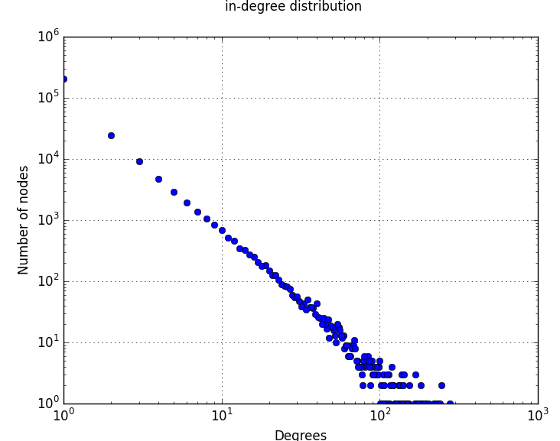

**Out-degree distribution**

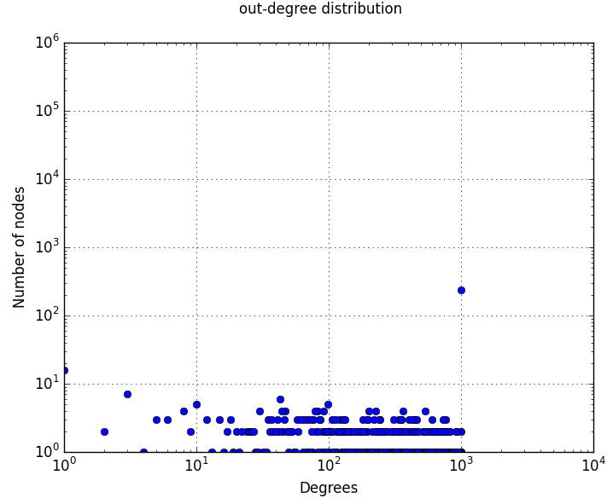

**Power law**

Calculating best minimal value for power law fit, I got these values:

Alpha exponent of in degree distribution: -2.23090496139

Alpha exponent of out degree distribution: -1.84436355593

**Bridges**

Tried with the bridge detection algorithm mentioned in the text book, but aborted the execution after close to 22 hours of continuous processing without any results.

**3-cycles**

Total number of 3-cycles: 258509

**Diameter**

The sampled diameter of the graph is 7

**Visualizing effect of random edge removal on largest connected component size**

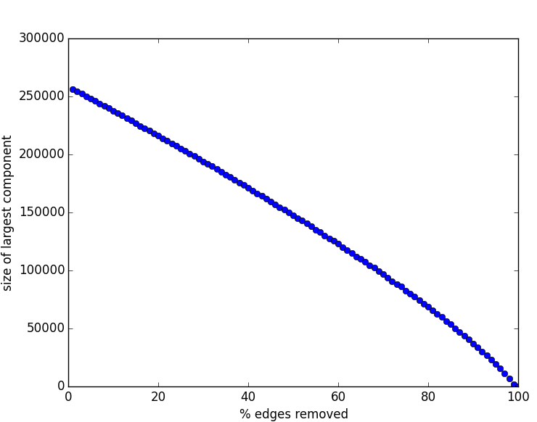

**P3 Network Measures**

Clustering coefficients of crawled network:

Local clustering coefficient = 0.067029

Global clustering coefficient = 0.010442

**Centrality**

**Page Rank**

|  |  |  |
| --- | --- | --- |
| No | Node ID | Page Rank Centrality |
| 1 | 678 | 7.69E-06 |
| 2 | 681 | 7.68E-06 |
| 3 | 9708 | 7.67E-06 |
| 4 | 692 | 7.49E-06 |
| 5 | 558 | 7.49E-06 |
| 6 | 315 | 7.38E-06 |
| 7 | 37 | 7.36E-06 |
| 8 | 297 | 7.30E-06 |
| 9 | 298 | 7.28E-06 |
| 10 | 24419 | 7.25E-06 |

**Degree centrality**

|  |  |  |
| --- | --- | --- |
| No | Node ID | Degree centrality |
| 1 | 605 | 0.000947746 |
| 2 | 297 | 0.000947746 |
| 3 | 692 | 0.000932273 |
| 4 | 401 | 0.000912931 |
| 5 | 134 | 0.000881984 |
| 6 | 2 | 0.000847169 |
| 7 | 645 | 0.000789144 |
| 8 | 61 | 0.000754329 |
| 9 | 1455 | 0.000746592 |
| 10 | 1449 | 0.000738855 |

**Eigen Vector Centrality**

|  |  |  |
| --- | --- | --- |
| No | Node ID | Eigenvector centrality |
| 1 | 605 | 0.094956883 |
| 2 | 476 | 0.089509002 |
| 3 | 2 | 0.08719305 |
| 4 | 965 | 0.08532927 |
| 5 | 692 | 0.084466795 |
| 6 | 134 | 0.081707412 |
| 7 | 1010 | 0.079477697 |
| 8 | 1057 | 0.07692632 |
| 9 | 410 | 0.076492721 |
| 10 | 695 | 0.076085917 |

**Rank correlation – Spearman**

*Columns: dc pc ec*

[[ 1. 0.65818536 0.43262553]

[ 0.65818536 1. 0.22420601]

[ 0.43262553 0.22420601 1. ]]

**Jaccard similarity**

**P4 Network Models**

**Crawled Graph**

Local clustering coefficient = 0.067029

Global clustering coefficient = 0.010442

Average path length = 3.986000

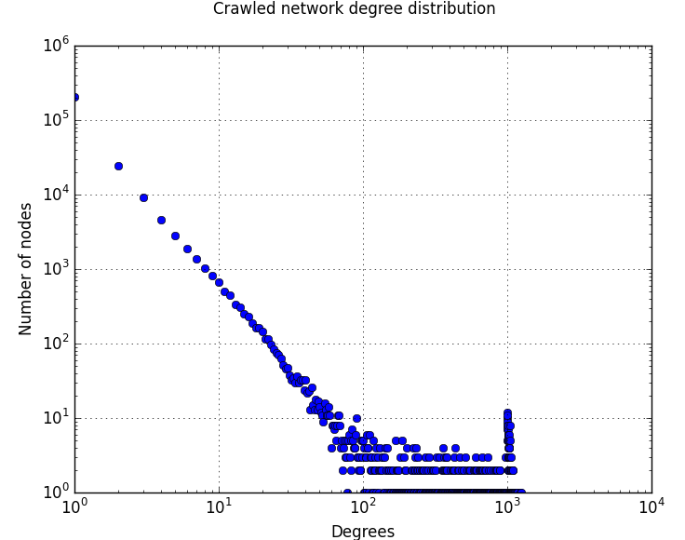

**Random Graph Model**

Local clustering coefficient = 0.000012

Global clustering coefficient = 0.000015

Average path length = 10.294550

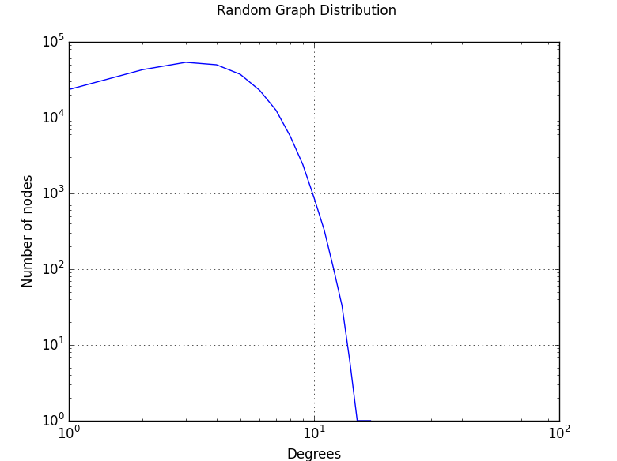

**Preferential Attachment Model**

Local clustering coefficient = 0.000377

Global clustering coefficient = 0.000106

Average path length = 6.185000

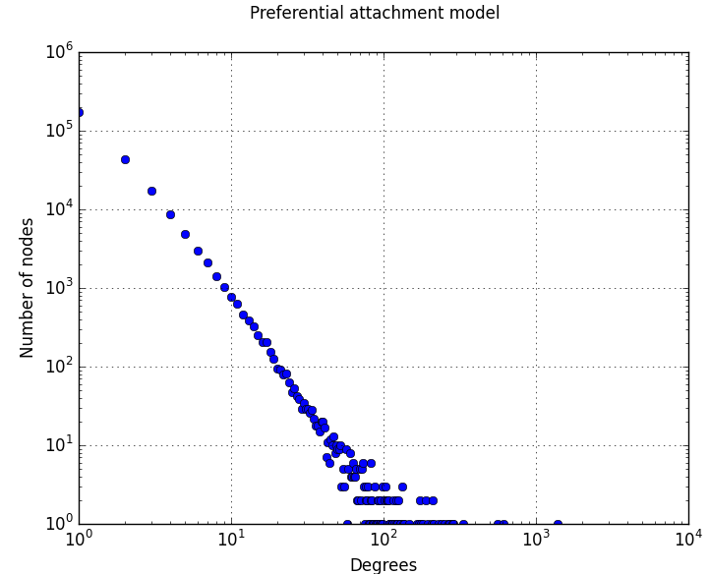

**Small World Model**

Local clustering coefficient = 0.047956

Global clustering coefficient = 0.039214

Average path length = 10.308500

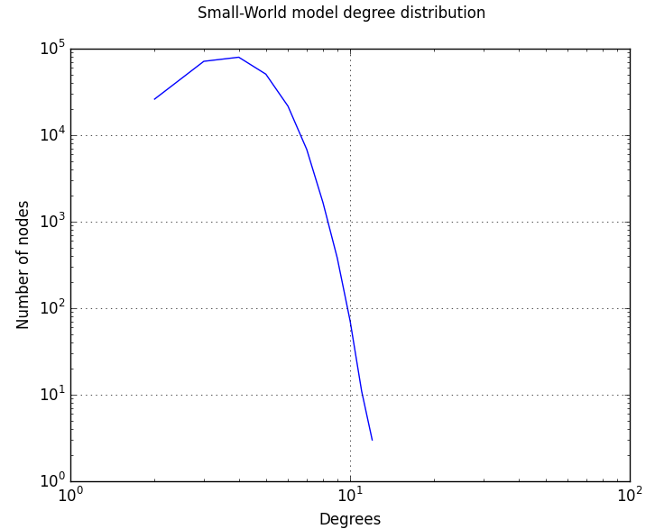

**Comparison**

|  |  |  |  |
| --- | --- | --- | --- |
| **Model** | **Local CF** | **Global CF** | **Average Path Length** |
| Crawled Graph | 0.067029 | 0.010442 | 3.986000 |
| Random Graph Model | 0.000012 | 0.000015 | 10.294550 |
| Small World Model | 0.047956 | 0.039214 | 10.308500 |
| Preferential Attachment Model | 0.000377 | 0.000106 | 6.185000 |